NATIONAL UNIVERSITY OF MODERN LANGUAGE ISLAMABAD
Lab 09


Submitted to:
Sir Hassan Shah
Submitted by:
Zulqarnain Hassan
Roll No: …………………… SP21379
Subject: …………………… computer network
Department: ……………… BSSE-5-Afternoon
Date: ……………………… 07-12-2024

Objectives
- Study the concept of STP in packet tracer and learn to configure the STP in switches
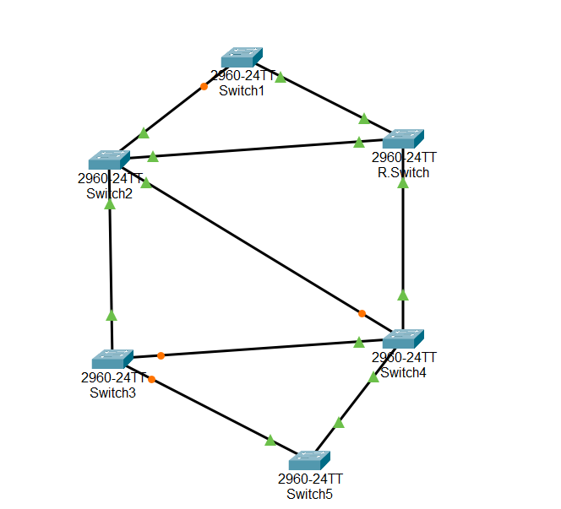
Enable Spanning Tree Protocol
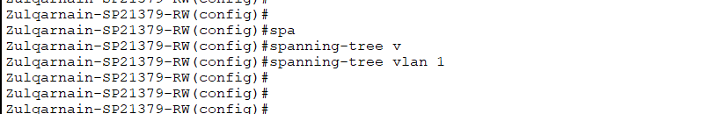
Set Bridge Priority: To force a specific switch as the root bridge:
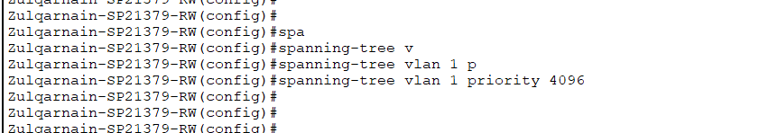
View Spanning Tree Status:
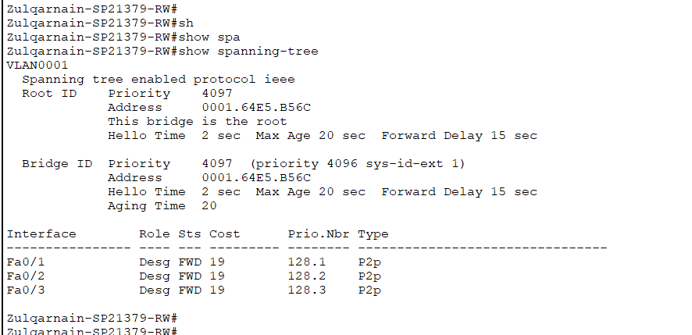

Enable rapid spanning tree


Set inter-switch ports as trunk ports to allow VLAN traffic to propagate correctly:
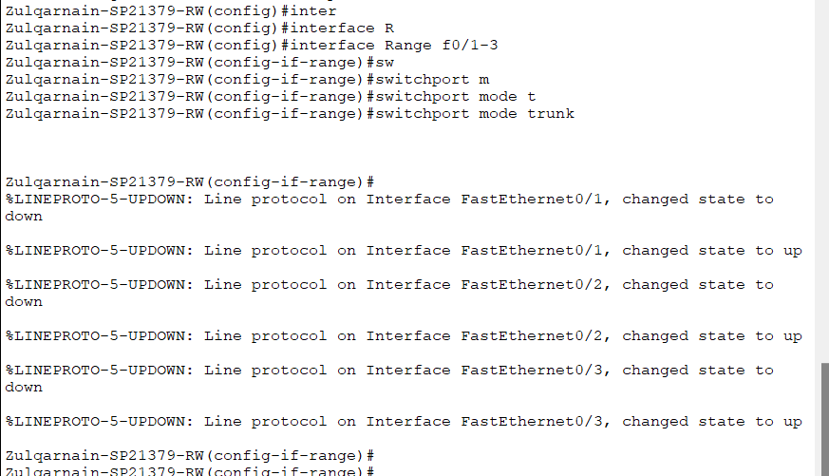
Disconnecting different switches

Disconnect Switch1 and R.Switch(root switch)
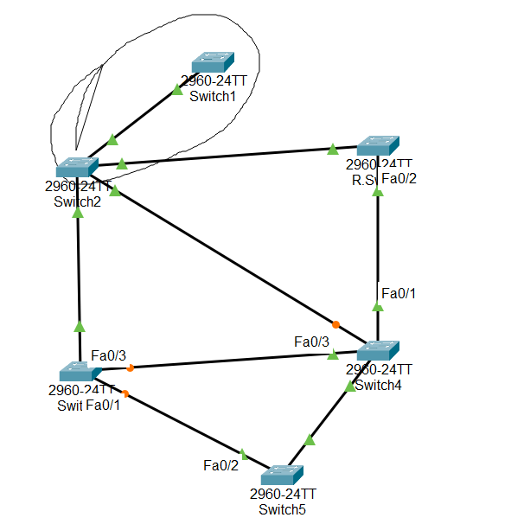
Also disconnect Switch2 and Switch3
